Kaya (coconut jam)

A coconut jam that’s eaten with butter, toast and soft boiled eggs in Singapore.

Ingredients

Method

The long

And the short: for the experienced cook

Special handling

Ingredients

The eggs

The sugar

Pandan leaves

The Bain Marie

The consistency of Kaya

# Ingredients

4 large eggs

220 ml coconut milk

100 g palm sugar (aka: gula jawa, gula melaka) *

75 g pandan leaves (weight when wet after a thorough wash)

¼ teaspoon salt

Makes about 500ml of kaya.

Fits 2x 8.5oz mason jars

# Method

## The long

1. Set up a double boiler: <https://www.wikihow.com/Make-a-Double-Boiler-(Bain-Marie)>
2. In the main container (Bowl A), add coconut milk, palm sugar and salt. Add pandan leaves - bruise and cook. Mix until palm sugar has dissolved (about 20 mins)
3. In a large bowl, beat eggs (Bowl B)
4. Add a ladle of coconut milk mixture (contents of Bowl A) to eggs (Bowl B). Whisk quickly. Repeat
5. Now add egg and coconut milk mixture (ie add Bowl B contents to Bowl A). Whisk quickly to prevent lumps
6. Scrape down sides and keep whisking
7. In 20-30 mins or so, the custard should thicken
8. Once it is the right consistency (like custard: thicker than pancake batter), remove from heat. It will continue to set as it cools
9. Store in clean jars, will keep about a week in the fridge (once cool).

## And the short: for the experienced cook

This is like making a custard. Use a bain-marie (double boiler). Melt palm sugar in coconut milk, and add salt. Add pandan leaves and bruise to release flavour. Temper the beaten eggs, then add tempered eggs to main pot. Would be a good time to remove pandan leaves. Stir out lumps. Custard should thicken in 20-30 minutes. Transfer to clean containers.

# Total cooking time

About 50 mins.

* About 20 mins for heating the coconut milk.
* About 20-30 mins for thickening the custard.

# Special handling

## Ingredients

### The eggs

Since there are so few ingredients, I try to use the best eggs I can. I settled for cage-free grade A large eggs.

### The sugar

Gula Jawa - if you use this, it comes in a block so you’ll have to cut it up to make it melt better.

Available at Ranch 99.  
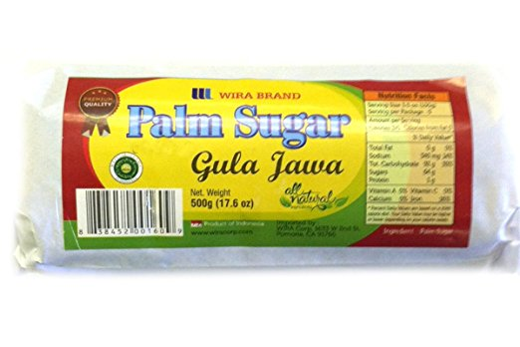

Coconut sugar also works.

### Pandan leaves

You can find this in the frozen section at Ranch 99.

### The Bain Marie

Make sure the water level in the bottom container does not touch the bowl sitting atop. This would cause the custard to set unevenly in the top bowl.

### The consistency of Kaya

If lumps form, you can

1. Whisk it away
2. Press the kaya through a strainer
3. Use an immersion blender

### Storage

Use glass containers. I boiled them for 15 minutes and dried it off before use.

After adding the kaya, I let it cool for 1.5 hours, added the lids and boiled the entire lot again for another 20 minutes.